DIS-Basket-Apache-Burden

Apache children’s burden basket of the last quarter of the 19th century.

This burden basket has an authentic Apache banded design with three horizontal encircling geometric bands (See Tanner 1982: 38-39. Its 19th century age is indicated by the scalloped-rim bottom patch “with a piece of red [trade] cloth under the patch and showing at this edge” (Tanner 1982: 39). Deer hide chamois fringes distinguish the rim. This basket measures approximately 7 1/4" tall (not including the fringes) x 8 3/4" diameter. Condition is good for its age. It does have some wear from age and use.

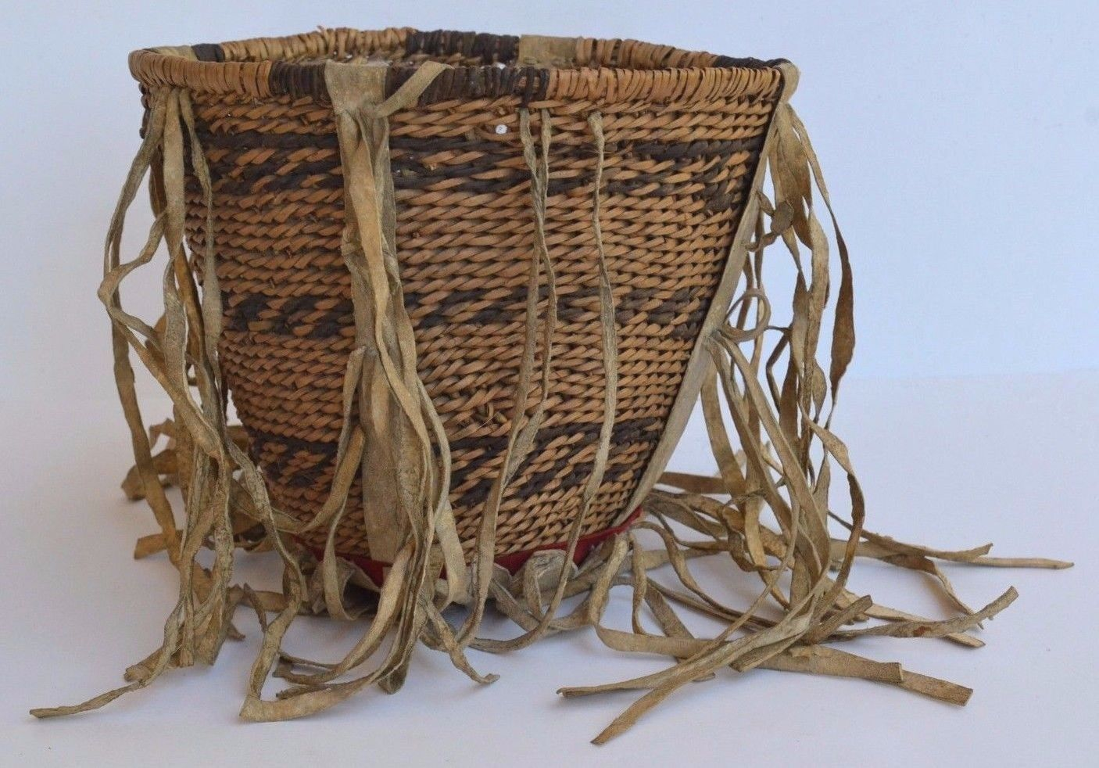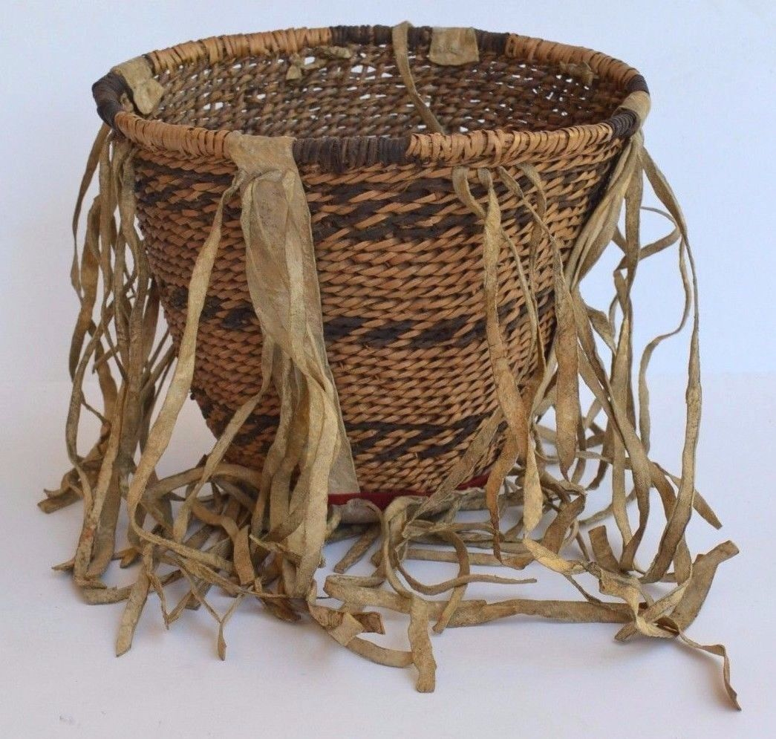

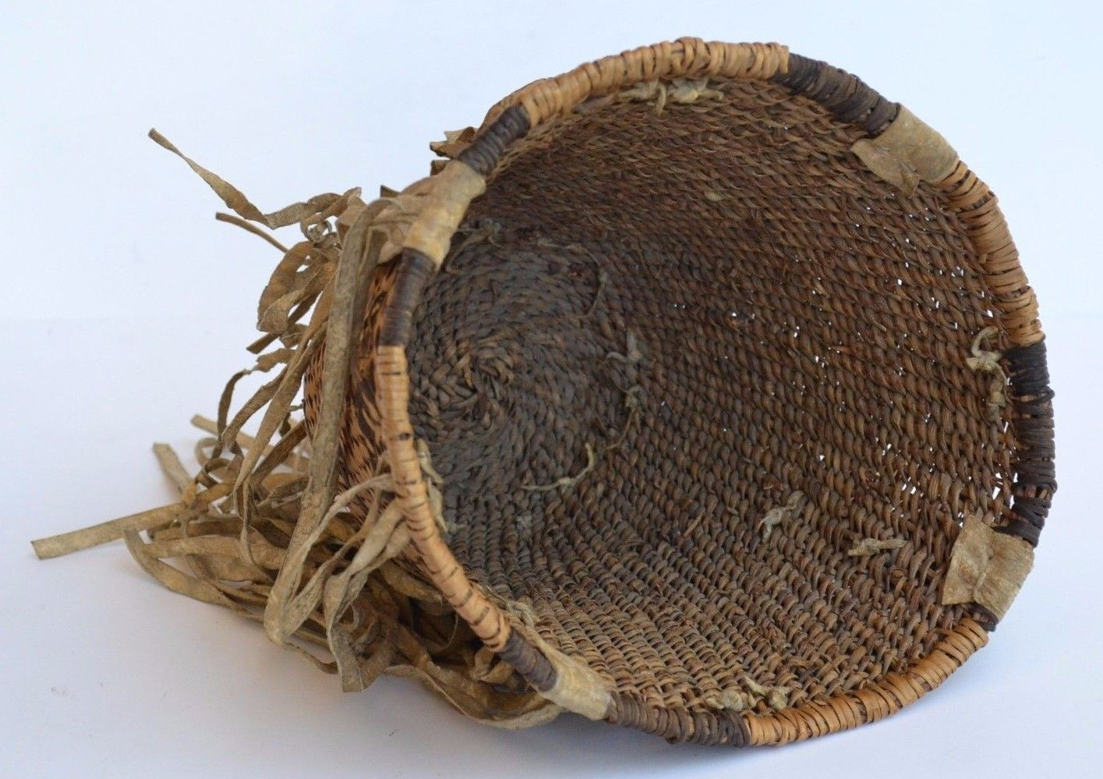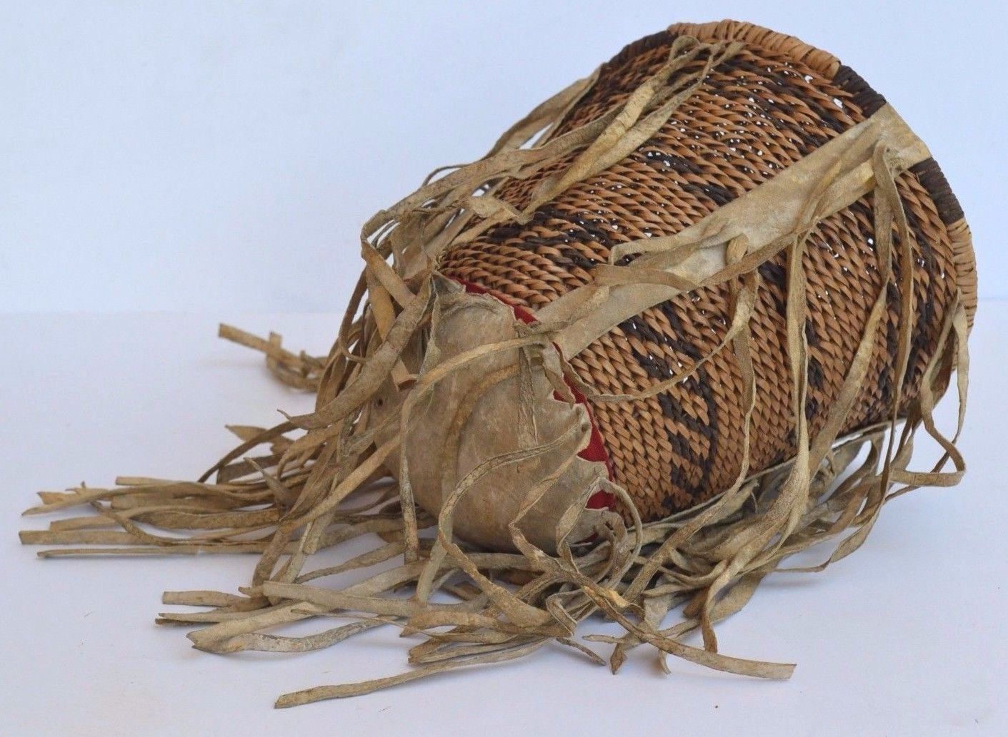

The burden basket of the Native American Apache tribe is one of the most recognized baskets of American Indians. Traditionally, burden baskets were originally used in everyday life for gathering wild foods and harvesting crops like corn. Burden baskets are also an integral part of Apache history being used in their rituals and ceremonies. This basket is 8 3/4" in diameter by 7 1/4" tall. Small burden baskets like this one were given to Apache children by their parents. Burden baskets are very labor-intensive to weave. According to Apache tradition, burden baskets are always cone-shaped, with a flat or rounded bottom. Buckskin was added to enhance the basket. Burden baskets almost always have a buckskin strap that is used to carry the basket. A traditional custom of the Apache is to hang these baskets outside the home so that visitors to the house could place their burdens in the basket before they entered. The saying "leave your burdens at the door" originated with these baskets. The burden basket is a symbol of pride for the Apache people

This is a very rare piece of Native American history because it is a craft of an older generation that not many young people are continuing. Authentic Apache basket.

Reference

Tanner, Clara Lee. 1982. *Apache Indian Baskets*. Tucson: University of Arizona Press.

|  |  |  |  |
| --- | --- | --- | --- |
| Antique Native American Indian Apache Burden Basket Circa 1900 - 20's [See original listing](http://www.ebay.com/itm/Antique-Native-American-Indian-Apache-Burden-Basket-Circa-1900-20s-/252124017928?ssPageName=STRK%3AMEBIDX%3AIT&_trksid=p2047675.l2557&nma=true&si=7sZbPHdxE%252Fz1rQIaYnKLbGzWSuE%253D&orig_cvip=true&rt=nc) | | | |
| |  |  | | --- | --- | | |  | | --- | |  | | | |  |  |
|  |  |
|  |  |
|  |  |
|  |  |
|  |  |
|  |  |
|  |  |
| Item condition:  Used |  | | |
| Ended:  Oct 20, 2015 , 8:30PM |  | | |
| Winning bid:  US $107.72  [ [7 bids](http://offer.ebay.com/ws/eBayISAPI.dll?ViewBids&item=252124017928&rt=nc&_trksid=p2047675.l2565) ] |  | | |
| Shipping:  $15.00 Expedited Shipping |  | | |
| Item location:  Rocklin, California, United States |  | | |
| Seller:  [rnjtreasures](http://www.ebay.com/usr/rnjtreasures?_trksid=p2047675.l2559) ([3212](http://feedback.ebay.com/ws/eBayISAPI.dll?ViewFeedback&userid=rnjtreasures&iid=252124017928&ssPageName=VIP:feedback&ftab=FeedbackAsSeller&rt=nc&_trksid=p2047675.l2560) ) |  | | |